

**SOCIETY MANAGEMENT SYSTEM**

Submitted in partial fulfillment of the requirements of the degree of

Bachelors of Engineering in Information Technology

By

**YASH PATEL**

**NIRAJ PATEL**

**ABHISHEK SAWALKAR**

Supervisor

**PROF. HARSH BHOR**



#### DEPARTMENT OF INFORMATION TECHNOLOGY

**K.J. SOMAIYA INSTITUTE OF ENGINEERING AND INFORMATION TECHNOLOGY, AYURVIHAR, SION, MUMBAI-22**

**2020-2021**

 

# CERTIFICATE

This is to certify that the project entitled “**SOCIETY MANAGEMENT SYSTEM EMBEDDED WITH IOT**” is a Bonafide work of students Yash Patel, Niraj Patel, Abhishek Sawalkar submitted to University of Mumbai in partial fulfillment of the requirement for the award of the degree of Bachelor of Engineering in Information Technology.

Prof. Harsh Bhor

Project Guide

Department of Information Technology

Dr. Radhika Kotecha Dr. Suresh Ukarande

Head of Department Principal

Place: Sion, Mumbai-400022 Date:

# Project Report Approval for B.E.

This project report entitled “**Society Management System embedded with IOT**” by

**Yash Patel (57)**

**Niraj Patel (56)**

**Abhishek Sawalkar (64)**

is approved for the degree of Bachelor of Engineering in Information Technology.

Examiners: 1.

2.

Date:

Place: Sion, Mumbai-400022.

# DECLARATION

We declare that this written submission represents our ideas in our own words and where others' ideas or words have been included, we have adequately cited and referenced the original sources. We also declare that we have adhered to all principles of academic honesty and integrity and have not misrepresented or fabricated or falsified any idea/data/fact/source in our submission. We understand that any violation of the above will cause disciplinary action by the Institute and can also evoke penal action from the sources which have thus not been properly cited or from whom proper permission has not been taken when needed.

### 

### Yash Patel



**Niraj Patel**

### 

### Abhishek Sawalkar

Date:

Place: Sion, Mumbai-400022.

# ACKNOWLEDGEMENT

We would like to convey our sincere thanks to everyone who guided us throughout this project endeavor, before we present our project entitled “**SOCIETY MANAGEMENT SYSTEM**”.

We wish to express our sincere thanks to **Dr. Suresh Ukarande**, our Principal, for providing us with all the necessary facilities for the research.

We place on record our sincere thank you to **Dr. Radhika Kotecha**, Head of Department, for the continuous encouragement.

We are also grateful to **Mr. Harsh Bhor**, Project Supervisor. We are extremely thankful and indebted to her for sharing expertise, and sincere and valuable guidance and encouragement extended to us.

We take this opportunity to express gratitude to all the Department faculty members for their help and support. We also thank our parents for unceasing encouragement, support and

attention.

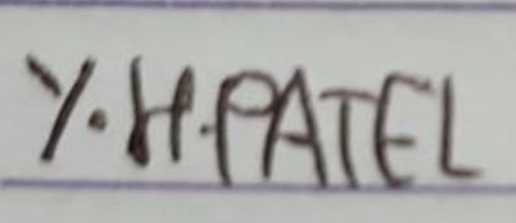

**Yash Patel**



**Niraj Patel**



**Abhishek Sawalkar**

Date:

# ABSTRACT

“Simplicity is the ultimate sophistication”. Housing Society Management System exactly follows this phrase and aims at making the current situation in the society simple and efficient. Society Management System reduces the conflicts that arise within the society by providing facilities such as online voting system, online hall allocation, etc. It automates certain attributes that occur within the society and makes it easy for the members of the society an easy access to the society happenings and on goings. A housing society management and billing project that effectively manages and handles all the functioning of a cooperative housing society. The software system can store the data of various flat owners and their family members along with their images. The system also maintains and calculates the society maintenance as well as parking, cultural funds, emergency funds and other charges and adds them automatically in individual flat bill. The system needs an administrator to input various flat owner data and billing amounts into it. The rest of the work is done by the system on its own. The system consists of automatic bill generation facility. It calculates various associated costs, adds them up and provides a bill accordingly

# TABLE OF CONTENTS

|  |  |  |
| --- | --- | --- |
| **Chapter No.** | **Title** | **Page No.** |
|  | **List Of Abbreviations** | **9** |
|  | **List Of Figures** | **10** |
|  | **List Of Tables** | **11** |
| **1** | **INTRODUCTION**   * **1.1 Motivation** * **1.2 Scope** * **1.3 Objectives** * **1.4 Presently Used System** | **12 - 16**  **13**  **14**  **15**  **16** |
| **2** | **RELATED WORK**  **- 2.1 Related Research** | **17 - 19**  **18** |
| **3** | **ANALYSIS AND PLANNING**   * **3.1 Feasibility Study** * **3.2 User Characteristics** * **3.3 Functional Requirements** * **3.4 Non Functional Requirements** * **3.5 Interface Requirements** * **3.6 Project Scheduling** | **20 - 28**  **22**  **23**  **24**  **26**  **27**  **28** |
| **4** | **PROJECT ANALYSIS**   * **4.1 Use Case Diagram** * **4.2 Activity Diagram** | **30 - 33**  **31**  **32** |

|  |  |  |
| --- | --- | --- |
|  | **- 4.3 Entity - Relationship Diagram** | **33** |
| **5** | **IMPLEMENTATION AND RESULTS**   * **5.1 Implementation Details** * **5.2 Implemented Modules** * **5.4 Results** | **34 - 41**  **35**  **36**  **37** |
| **6** | **CONCLUSION AND FUTURE WORK**   * **6.1 Conclusion** * **6.2 Future Scope** | **42 - 44**  **43**  **44** |
| **7** | **REFERENCES**   * **7.1 References** * **7.2 Publications and Certificates** | **45- 50**  **46**  **50** |

### List of Abbreviations

### HTML - Hyper Text Markup Language

### CSS – Cascading Style Sheets

### JS – JavaScript

### Node MCU – “node” and “MCU” (micro**-controller unit)**

* Ldr sensor - **Light-Dependent Resistor Sensor**

### List of Figures

Figure 3.3.0 Functional Requirements - Page 24 Figure 4.1.0 Use Case Diagram - Page 31 Figure 4.2.0 Activity Diagram - Page 32

Figure 4.3.0 Entity Relationship Diagram - Page 33 Figure 5.3.0 SDLC Phases - Page 37

Figure 5.4.0 Home Page - Page 41 Figure 5.4.1 Login Page - Page 42 Figure 5.4.2 Registration Page - Page 42 Figure 5.4.3 Admin Dashboard - Page 43

Figure 5.4.4 Admin Manage Menu - Page 43 Figure 5.4.5 Admin Manage Reservation - Page 44 Figure 5.4.6 User Order Page - Page 44

Figure 5.4.7 Razorpay Page - Page 45 Figure 5.4.8 Profile Page - Page 45

### List of Tables

5.1.0 Task Distribution - Page 24

**CHAPTER 1**

**INTRODUCTION**

# Motivation

Society Management Software is the prominent need of our modern and enormous societies. It helps to reach maximum people at the same time and reduces the effort of physically reaching out to members. It is difficult to keep a track of each family living within a society and record the information manually in spreadsheets. In this case, society management software helps maintain the details of owners and tenants living in the apartment complex. If you want to reach out to any member at any given time, members can be contacted easily via the society management webpage, and thus communication is just a click away. The software helps keep a track of society maintenance dues, utility bills (where members are billed based on meter readings), society bills and invoices, income and expenses, and also helps track RD/FD maturity dates of member accounts. In the time of pandemic such as covid we can use such kind of approach for less human contact and the work done is accurate and efficient.

# Scope

Generally, in Society all the work is decided in meetings and maintenance bills, contact no of members are recorded on the papers. There is no automated system for doing all the things that generally happens in society, so that members can come to know what is happening in society. The Society Management System allows members to login with their own account and get updated with society happenings. Society Management System is the website portal to reduce conflicts among society members. The system has automated functionality for calculating monthly maintenance bill and member can view their bill status on their account. The main functionality of this project is that, there is a voting system for different society positions like Chairman; Treasurer Etc. Member can vote the candidates that are standing for different roles in society. Not only the web site but we have merged the website with iot based automated system for the society that can result in low human contact and efficient work saves time too. The web application mainly featured with fruitful solution for day-to-day notifications for meetings, water management, electricity management, parking, miscellaneous contacts, security alerts and high priority communication. It will definitely reduce the human efforts and errors to increase crystal clear transparency between society members and management. . It will be very much reliable way of communication irrespective of time and location. One can remain connected with society members around the clock. In addition to that it will save time, paper work, and human efforts and offers reliability.

# Objectives

### ****Manage administrative tasks effectively****

Ideal for use by society managing committee groups, the society management software keeps a track of all the society’s billings and keeps a check on the society members, such as tracking members who have not paid their maintenance dues, etc. It manages the data of tenants and owners and records the data of visitors who enter the apartment complex during the day. Thus, today people are excited about comprehensive housing society management software – to ensure that society administrative tasks are managed effectively and to get rid of complex paperwork and manual accounting tasks.

### ****Reach maximum people at the same time****

Society Management Software is the prominent need of our modern and enormous societies. It helps to reach maximum people at the same time and reduces the effort of physically reaching out to members. It is difficult to keep a track of each family living within a society and record the information manually in spreadsheets. In this case, society management software helps maintain the details of owners and tenants living in the apartment complex. If you want to reach out to any member at any given time, members can be contacted easily via the society management app, and thus communication is just a click away.

### ****Track income, expense, and other things****

Let us see what all society management software can track. The software helps keep a track of society maintenance dues, utility bills (where members are billed based on meter readings), society bills and invoices, income and expenses, and also helps track RD/FD maturity dates of member accounts.

* **Iot based automated system for society**

In the time of pandemic such as covid we can use such kind of approach for less human contact and the work done is accurate and efficient

# Presently Used System

The current system for a society is based on our traditional way keeping records and details on paper and registers. Access of these details and papers are not granted to common member in absence of the authority. For voting for various designations (secretary, treasurer, chairman etc.) in society members need to be present on site for voting. Due to some unavoidable reasons some members cannot cast vote. Proposed system has a facility for voting online which will provide anytime anywhere access. Booking a hall for celebration in a society was tedious work as details were on paper and were only accessible only to the authority which may create confusion when two or more people want to celebrate in same hall. We studied Housing Society Management System [. This software system generates bill automatically and manually. It creates bill of all members at single click. In this system bills can be generated as per multiple of months i.e., monthly, quarterly half yearly etc. due day of bills can be assigned. Housing Society Management System does not allow user to cast vote or manage nominees and does not have a provision for hall allocation. This software concentrates mainly on generation of bills whereas our system integrates various other features of society which are exact replica of the real happenings in the society. Including features like voting, hall allocation, report generation etc. Our system provides more efficient and accurate results and can be accessed anywhere anytime.

**CHAPTER 2**

**RELATED WORK**

# 2.1 Related Research

Study of Implementation of **Society Management System**: This application was developed by Shivganga Gavhane, Rutuja Vatharkar, Swati Sonar, Pratiksha Patil. This was an android application which contained features like Notice Board, Calendar, Contact, Maintenance, Financial Report, Complaint or Suggestion. To overcome the drawbacks of the existing system, the application provided an efficient way. It also had a special feature called “Push Through Notification” which helped in efficient usage of roles to the society members

**Housing Society Management Web Application with recommendation system:** This application was developed by Saurabhi Raut, Priyanka Pawar, Masira Shaikh, Neha Bhat, Prof. P.N. Kalavadekar. This web application helped in improving the sociality of the society by helping them interact with each other by becoming a member of a cultural or sports group. This application also helped the residents to give complaints and suggestions via the application instead of personally meeting the chairman to give them. Alos once the complaint or suggestion is resolved , it is updated in the application. Due to this, the residents are always updated of the current affairs regarding the society matters and they can also participate in various events

**Society Management Application on Android**: This application was developed by Rahul Bhagwat, Aashay Bharadwaj, Vivek Harsode, Anurag Chawake, Mrs. Deepali Bhanage. This android application contained features like QR code authentication, Online Payment, Society Maintenance Amount. To surmount the drawbacks of the subsisting system, they provided a more astute and efficient way to handle the critical issues by truncating efforts and advancements in reliable communication. Different functions in the society like Complaints, Notices, Meetings, Rules, Suggestions, Miscellaneous Contacts were available within a single visual perception so that users can visually examine it and make utilization of it whenever is obligatory.

Housing Society Management: This application was developed by Shantanu Kudale Chandan Amarnani, Harshal Sawakare, Shubhankar Kokate, Sujata Kadu. To overcome the drawbacks of the current system this project provided a simple and efficient way of communication via an android app. This application had a feature which enabled the person-to-person communication. Different functions within society like Complaints, Notice, Meetings, Rules, Suggestions, Miscellaneous Contacts were available at a glance so that the residents can use any of the features easily. This application also reduced the work of the admin by providing calendar events so that admin did not have to keep track of the information's reachability.

Robart A. Sowah and Seth Y. fiawoo., has discussed The components of designed and developed system include a web application through which workers would input data at their various workplaces a database hosted on a central server that would store information entered by workers an application programming interface (API) that would take requests from the Android application, query the database and serve the results back to the Android application and an android application that processes and displays results to users. The android application is developed using Eclipse in conjunction with android SDK tools. The application retrieves data from a database per user request and displays the retrieved information on an android device. Users of this application would be able to analyse data quicker hence make quick decisions as they would not be drowned in a flood of detailed information. There is also an added benefit of having access to company data on the go.

Jarle Hansen, Tor Gronli., have focused on principle of cloud computing and distributed computing. There are many handful technologies, which push data or content on mobile devices/tablets. The need of technologies studied are Google Cloud Messaging (GCM), C2DM (Cloud to Device Messaging) and Xtify is for authenticating a user, as well as handling all aspects of messages and delivery to the target application on the target device. The basic notification application is implemented using Google Cloud messaging.

YavuzSelimYilmaz., provides a facility using GCM (Google Cloud Messaging) to send data from server to Android mobile device of user, and also receives messages from other devices within a network according to Android developer website, “a service that helps developers sends data from servers to their Android applications on Android devices.” Hence, the overall purpose and scope of this project is reachable by Push notification technology (GCM).

**CHAPTER 3 ANALYSIS**

**AND PLANNING**

# Feasibility Study

The most important part of designing any management system is when the end-user or admin uses the system, they can easily get through all the aspects of the system and for that, a combination of graphical user interface and system’s back-end should coordinate perfectly.

In our project, we have used HTML/CSS/JS as a front-end technology with which we created responsive and interactive graphical user interface that helps both end-user and admin to do their respective tasks.

We have used the PHP framework for back-end systems. For any application there is a need for data, therefore it should be stored somewhere so that when data is required it can be fetched from the database and therefore, we used phpMyAdmin to connect our back end with the mysql as our database. All the database operations like data insert, update, retrieval and deletion done using mysql queries.

# User Characteristics

There are two types of user roles in the system Admin and Member

The Admin has the following permissions:

* + Manage/Add/Edit/Delete Users
  + Manage/Add/Edit/Delete Bills
  + Manage/Add/Edit/Delete Notice Board
  + Manage/Delete Contact Us Messages

The Member has the following permissions:

* + Do Registration
  + Contact Us
  + Edit Profile
  + View3 own information/bill/noticeboard/water level

# Functional Requirements

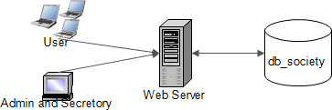

**Figure 3.3.0**

As can be seen in the system figure 3.3.0 diagrammed above, each of the three system components essentially provides a layer of isolation between the end user and the database. The motivation behind this isolation is twofold. Firstly, allowing the end user to interact with the system through a rich interface provides a much more enjoyable user experience, particularly for the non-technical users which will account for the majority of the system’s users. In addition, this isolation layer also protects the integrity of the database by preventing users from taking any action outside those which the system is designed to handle. Because of this design pattern, it is essential to enumerate exactly which functions a user will be presented with and these functions are outlined below, grouped by component.

**Society management system**

Users of the website, must be provided the following functionality:

* + Create an account.
  + Manage their account.
  + Log in to the system.
  + Navigate the whole website even the noticeboard
  + Register a complain.
  + View the maintenance bill and the water bill.
  + The member should only have the right to view and not edit.
  + Admin has the right to Remove an member or add an member ..
  + Both admin and member should be able to view the water level in the water tank
  + Admin should be able to add notice or delete notice from the notice board.

As the goal of the system is to make the process of the society member easy to colllabrate with the other society member and the admin i.e the secretory of the society and have less human interaction in the situation of the covide 19 we can depend on such system that will maintain social distance

**Admin interaction with the website.**

Admin has all rights to view as well as edit admin has the following rights

* + Add a new/update/delete society member .
  + Add a new/update/delete notice.
  + Update the maintenance bill.
  + Update the water bill.
  + Update information of the society member .

**Member interaction with the website.**

Society member has the right to view and provides the following functions:

* + Retrieve any information about the society member.
  + View the notice board .
  + View the maintenance bill
  + View the water bill.
  + View water level in the tank.

.

# Non Functional Requirements

Because the design patterns of the society management System are pretty much the standard for a web application, the non-functional requirements of the system are very straightforward. Although the front-end is written using HTML, the application is cross-compiled to HTML and CSS, along with a PHP backend, all of which are supported by any reasonably well maintained web server, although we would recommend apache2 for live deployments.

All of the application data is stored in a MYSQL database, and therefore MYSQL must also be installed on the host computer. As with Apache2, this software is freely available and can be installed and run under most operating systems.

The server hardware can be any computer capable of running both the web and database servers and handling the expected traffic. For a society that is not expecting to see much web traffic, or possibly doing only a limited test run, an average personal computer may be appropriate. Once the site starts generating more hits, though, it will likely be necessary to upgrade to a dedicated host to ensure proper performance. The exact cutoffs will need to be determined through a more thorough stress testing of the system.

# Interface Requirements

**Admin interaction with website.**

Admin of the website should have all the rights to view edit and delete. The admin of the

Website is non other than the core member of the website they have the right to add a member

Delete a member edit a member.add/delete/edit the information of a member is also the work

Of admin and also add/delete/edit of the notice board and waterbill and maintenance bill

comes under the rights of the admin

**Member inertaction with the website:**

Member of the website should have the rights to view only. The member of the website are

The society member and they have the right to view the information of any society member

View the maintenance bill and view the water bill and also view the water level of the water

Tank and also view the notice board and also register a complain on the website comes under

The rights of the society member on the website

**Automation done using iot**

Time like this is very crucial as we are fighting corona virus we need to maintain social distance

i.e no human touch and this is possible if aur work is automated and there is no human touch so we have ensure this to our society by automating the system and we have automated our society with automatic water supply system as the water decreases below 50% the water supply starts automatically and the water level data is send to the database and from there the data is displayed on our website not only the automatic water supply system but we have also automated our street light as the intensity of the sunlight decreases the street light get switch on automatically

# Project Scheduling

#### Task Distribution

|  |  |  |
| --- | --- | --- |
| **TASK LIST** | **ASSIGNED TO** | **STATUS** |
| Defining Project | Yash Patel | Complete |
| Niraj Patel |
| Abhishek Sawalkar |
| Literature Review | Yash Patel | Complete |
| Niraj Patel |
| Abhishek Sawalkar |
| Survey Paper | Yash Patel | Complete |
| Niraj Patel |
| Abhishek Sawalkar |
| Project Plan | Yash Patel | Complete |
| Niraj Patel |
| Abhishek Sawalkar |
| Project Analysis | Yash Patel | Complete |
| Niraj Patel |
| Abhishek Sawalkar |
| Input Page Design | Yash Patel | Complete |
| Niraj Patel |
| Abhishek Sawalkar |
| Documentation of Synopsis | Yash Patel | Complete |
| Niraj Patel |
| Abhishek Sawalkar |

|  |  |  |
| --- | --- | --- |
| Implementation | Yash Patel | Complete |
| Niraj Patel |
| Abhishek Sawalkar |

**Table 3.6.0**

**CHAPTER 4 PROPOSED SYSTEM**

# Use Case Diagram

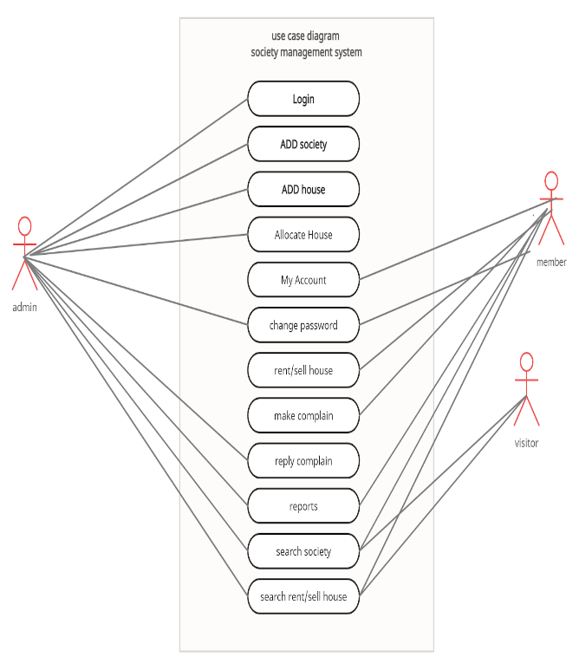

**Figure 4.1.0**

# Activity Diagram

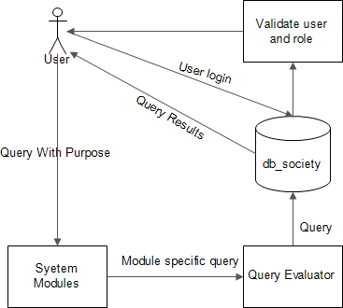

* 1. **Entity - Relationship Diagram**

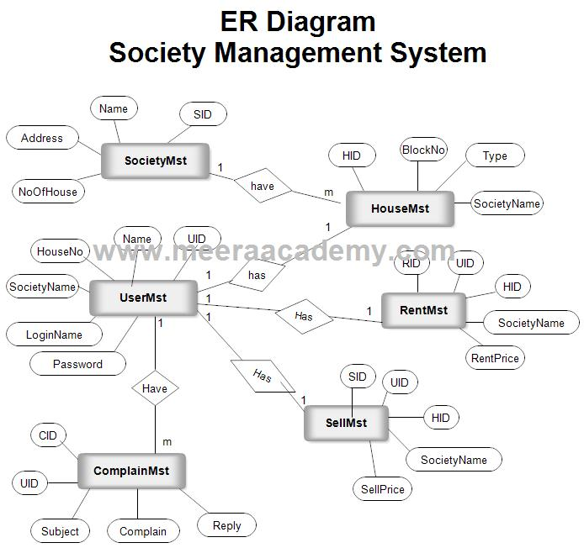

**CHAPTER 5**

**IMPLEMENTATION DETAILS**

**AND**

**RESULTS**

# Implementation Details

### Hardware Requirements:

* Window 10, 64bit
* CPU: (Intel i5/i7)
* Hard disk - 1 TB
* **Arduino** :It is an [open-source hardware](https://en.wikipedia.org/wiki/Open-source_hardware) and [software](https://en.wikipedia.org/wiki/Open-source_software) company, project and user community that designs and manufactures [single-board microcontrollers](https://en.wikipedia.org/wiki/Single-board_microcontroller) and [microcontroller](https://en.wikipedia.org/wiki/Microcontroller) kits for building digital devices. It’s hardware products are licensed under a [CC-BY-SA license](https://en.wikipedia.org/wiki/Creative_Commons_license), while software is licensed under the [GNU Lesser General Public License](https://en.wikipedia.org/wiki/GNU_Lesser_General_Public_License) (LGPL) or the [GNU General Public License](https://en.wikipedia.org/wiki/GNU_General_Public_License) (GPL),[[1]](https://en.wikipedia.org/wiki/Arduino#cite_note-1) permitting the manufacture of Arduino boards and software distribution by anyone. Arduino boards are available commercially from the official website or through authorized distributors.
* **Dc 5v water pump**
* **Relay board**
* **Jumper wire**
* **Ldr sensor**
* **Node mcu**
* **Ultrasonic sensor**
* **Breadboard**
* **Resistor**

### Software Requirements: -

* **Front End Technologies:** HTML/CSS/JS/BOOTSTRAP
* **Back End Technologies:** XAMPP, PHP
* **Platform:** Visual Studio Code
* **Version Control:** Git, GitHub
* **Operating System:** Windows 10
* **Arduino IDE**

# Implemented Modules

* **Login**: In the login module the members and admins login will be taken while they already registered on the website. Every member/admin will have a login id and password to login to the website.
* **Registration**: This module is displayed to the visitors to view their personal information as well as all the bills to be paid like maintenance bill, water bill etc. Also, member will be able to see the notice board of their respective society on our online society management website.
* **Admin Dashboard Management**: This module is for admin. Admin have rights to insert, update (modify) and delete the data in the database as per his/her necessary requirements.
* **Member Dashboard Management**: This module is for society members. Members have right to view their personal information as well as all the necessary information regarding the society.
* **Logout**: The last module describes that after placing an order or performing some actions on the website the customer will click the logout profile.
* **Contact Us**: Users can fill Contact Form for communication with admins in case of reviews.
* **Fully automated water supply system:** the website is connected with the iot based water supply system.the data is send using node mcu to the database of our system and then with the help of this data from our database we display the current water level system on our website as the water level of the tank of our society decreases below 50% the water pump will start automatically
* **Fully automated street light system:** as the intensity of sunlight decreases the lights will be automatically switch on in the evening and as the intensity increases in the morning the light will be switched off in the morning

# 5.3 RESULT



**Figure 5.4.0 Home Page**

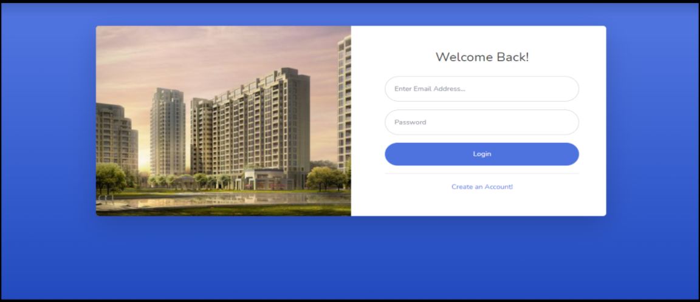

**Figure 5.4.1 Login Page**

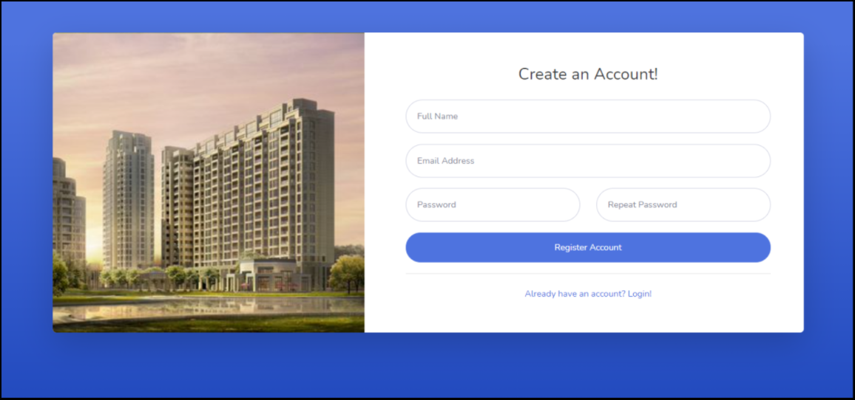

**Figure 5.4.2 Registration Page**

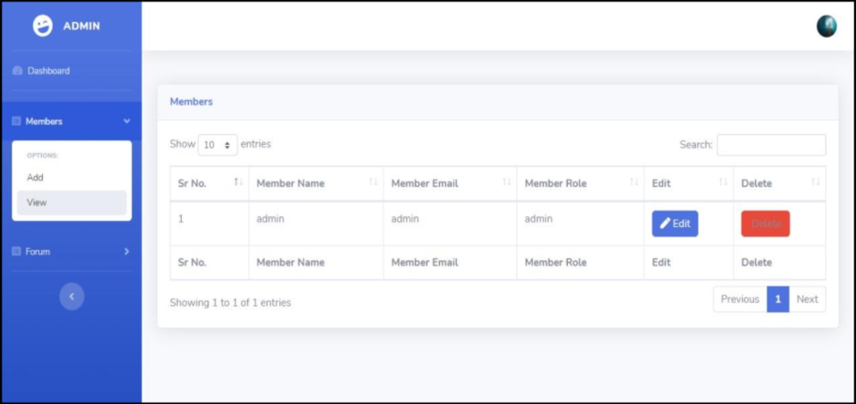

**Figure 5.4.3 Admin Dashboard Page.**

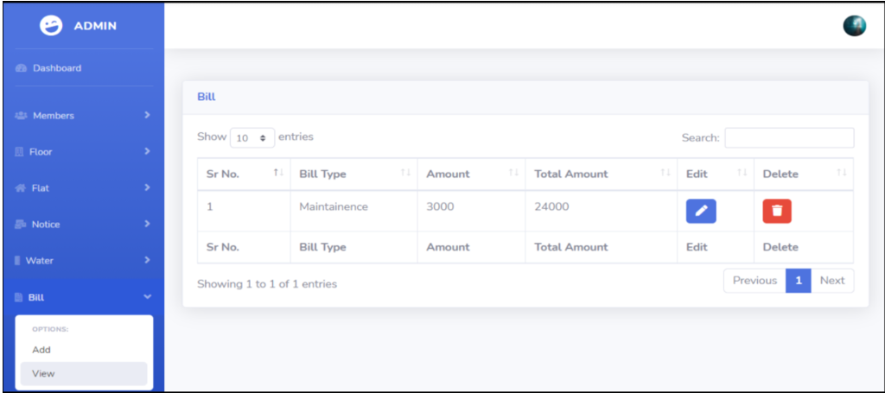

**Figure 5.4.4 Add member**

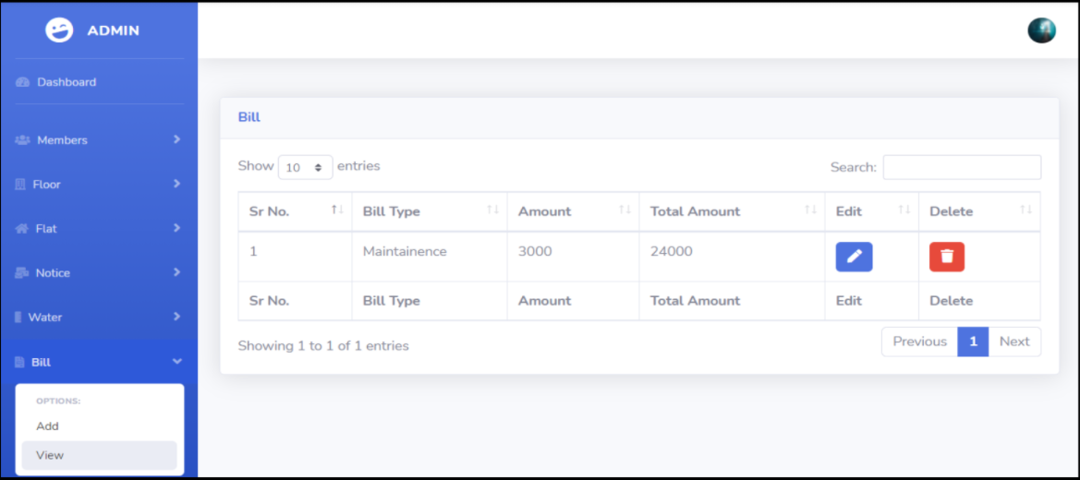

**Figure 5.4.5Display of maintenance and water bill**

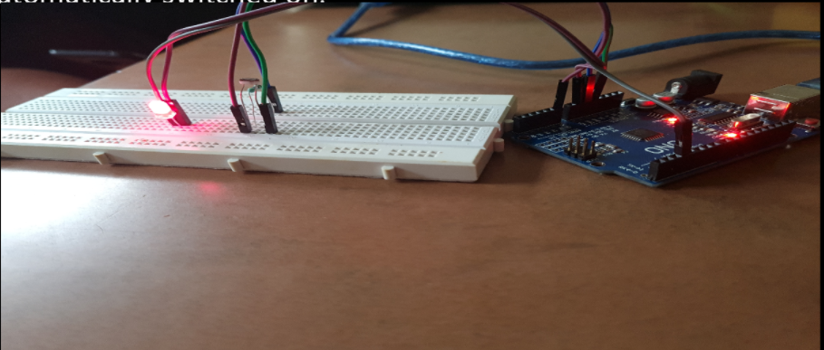

**Figure 5.4.5 Automated street light system**

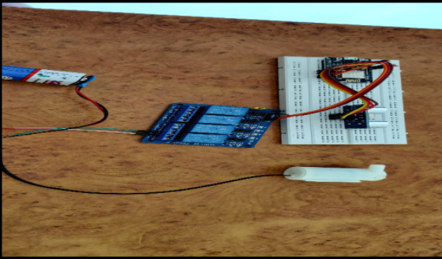

**Figure 5.4.6 Automated water pump**

**CHAPTER 6 CONCLUSION**

**AND FUTURE WORK**

# Conclusion

Thus, our website tries to comfort its users with easily understandable as well as essential functionalities. Here, both managing committee and residents have the same website  with the maintenance generation and financial report generation features disabled at the resident side. This is achieved by maintaining separate login type for both types of users. Both types of users have similar rights over remaining features like viewing and posting notices on the notice board, adding and getting notified by calendar events and accessing society member contacts and the miscellaneous contacts. Our application is implemented to help manage the affairs of a housing society by requiring the committee member to enter and save minimal amount of information. It will allow the members of the housing society to access information about a society, its residents and the managing committee on the go. Thus, this website provides a virtual tour of the society. Concept of data mining and artificial intelligence would be worked upon as a future work for our project .our project is also imbedded with iot based automatic street light and automatic water pump

# Future Scope

This project can be enhanced further by adding online payment facility for the members to reduce the extra work of the admin. The software is flexible enough to be modified and implemented as per future requirements. We have tried our best to pre- sent this free and user–friendly website to Society members. Message and Email alerts for various happenings in the society can be added to the system so that users do not miss the updates and happenings of the society. We can also add automatic water sprinkler using iot.

**CHAPTER 7 REFERENCES**

# References

# [1] BinPeng Jinming Yue, Chen Tianzhou, "TheAndroidApplicationDevelopmentCollegeChallenge "IEEE,2012, pp-1677-1681

# [2] [http://www.tutorialspoint.com/struts_2/basic_mvc_archit ecture.htm](http://www.tutorialspoint.com/struts_2/basic_mvc_archit%20ecture.htm)

# [3] [http://www.tutorialspoint.com/sdlc/sdlc_waterfall_model .htm](http://www.tutorialspoint.com/sdlc/sdlc_waterfall_model%20.htm)

# [4] Jarle Hansen, Tor-Morten Grønli, Gheorghita Ghinea,” Cloud to Device Push Messaging on Android: a Case Study”,ICAINA,2012,pp-1298-1303

# [5] Omkar Singh1, Aditee Lakhan2, Jyoti Gupta3, “Implementation of an Android Application for Management of a Housing Society”, IJECS,2015, vol4,pp-12383-12389 [6] Saurabh Malgaonkar, Vivek Maurya, Mukul Kulkarni, Gurtej Singh Majithia, “Multipurpose Android Based Mobile Notifier”, ICAECC,2014,pp-1-4

# [7] Seth Y.Fiawoo and Robert A. Sowah, “Design and Development of an Android Application to Process and Summarize Corporate Data”,IEEE,2012, pp-1-6

# [8] SHAO Guo-hong, “Application Development Research Based on Android Platform”,ICICTA,2014,pp-579-582

# [9] Yavuz Selim Yilmaz, Bahadir Ismail Aydin, Murat Demirbas, “Google Cloud Messaging (GCM): An Evaluation” IEEE,2014, pp-2807-2812

# Publications & Certificates

**1.** “Society Management System”, Volume 10, Issue 5, May 2021

, International Journal of Innovative Research in Science, Engineering and Technology (IJIRSET).

